**[Transient Analysis](http://www.zen22142.zen.co.uk/ltspice/transient.htm)**

DC Transient Charging a Capacitor

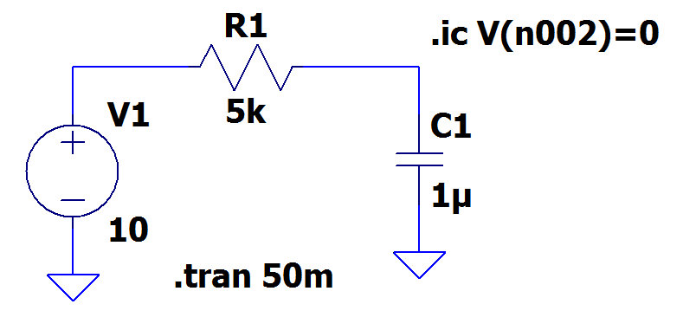

**.in** means initial condition



AC Transient



**Output :**



Phase φ = 360 * f * Δt = 360 * 1000 * 0.00001202 = 43.27°

**Import Spice Model**

[**https://www.youtube.com/watch?v=cp7deyHFUnQ&list=LLKquMlwGpuHA4hpluqUM6PQ&index=1&t=278s**](https://www.youtube.com/watch?v=cp7deyHFUnQ&list=LLKquMlwGpuHA4hpluqUM6PQ&index=1&t=278s)